Practical 24: Activities and Intents

Task 1:

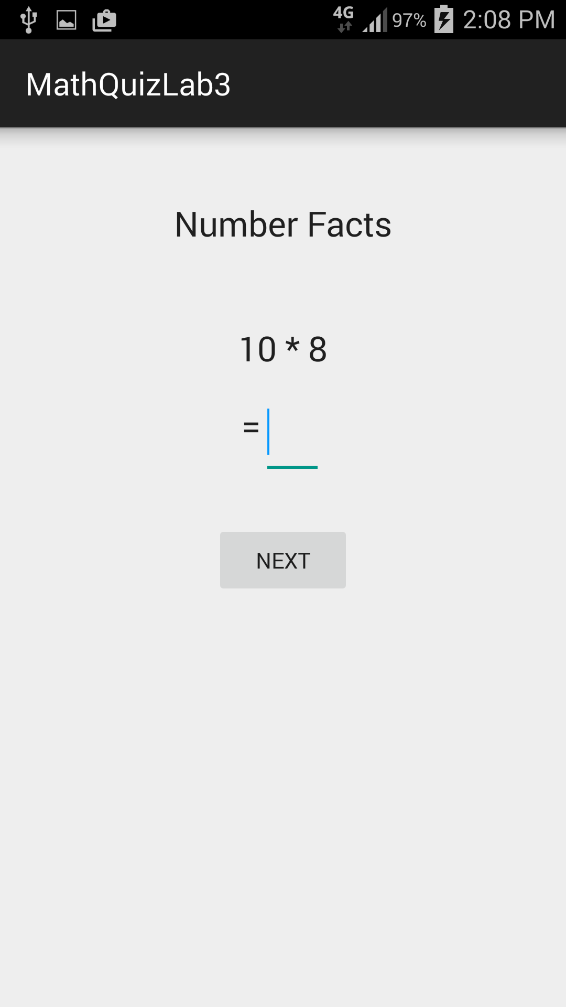 | 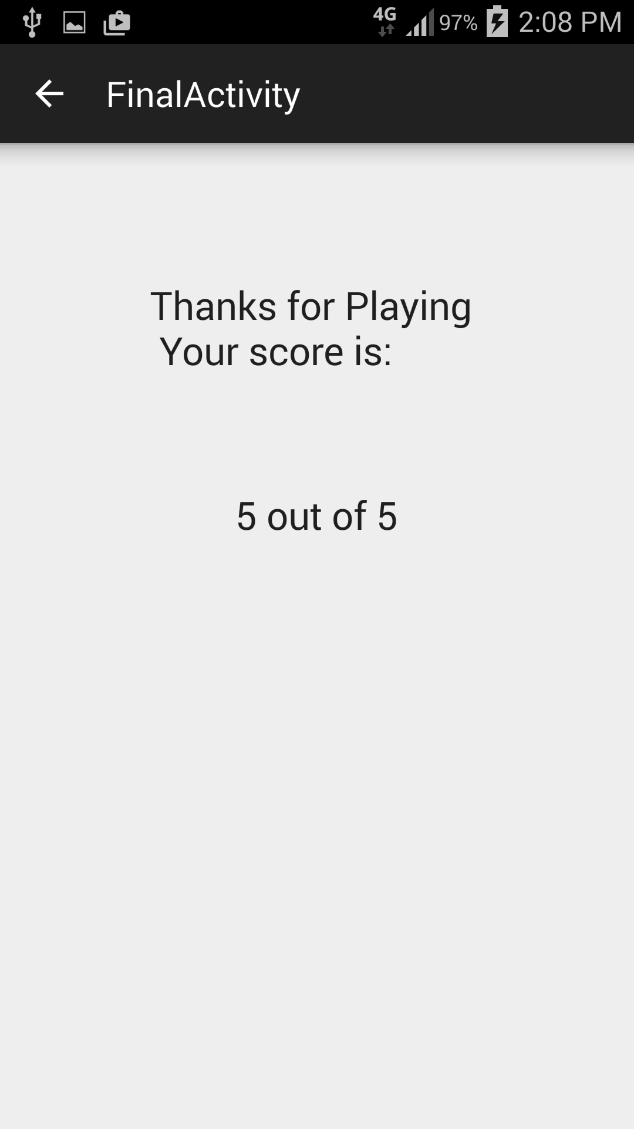
Main activity layout | Final activity layout

In this lab we are going to create a Maths Quiz testing your number facts.

Create the first layout; I used the following properties on my editText box. If you have trouble getting the soft keyboard to come up, make the text box wider.

<EditText
android:layout_width="40dp"
android:layout_height="wrap_content"
android:inputType="number"
android:textAppearance="?android:attr/textAppearanceLarge"
android:id="@+id/editText" />

Create a Question.java class, containing integer properties: number1, number2 and result. Generate a constructor, gets and sets and a toString. Android Studio will code this for you if you ask nicely.

Code a set up the questions method and loop around creating an array of 5 Questions.

I created a show question method and checked the question when the user hit the check button. It was tricky parsing the editText contents to an integer:
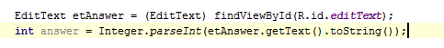

At the end of the questions I would like to send the user to a new activity screen and pass the current score with them.

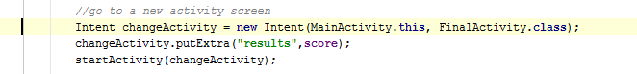

In the new activity which I called FinalActivity.java, I receive the data as follows
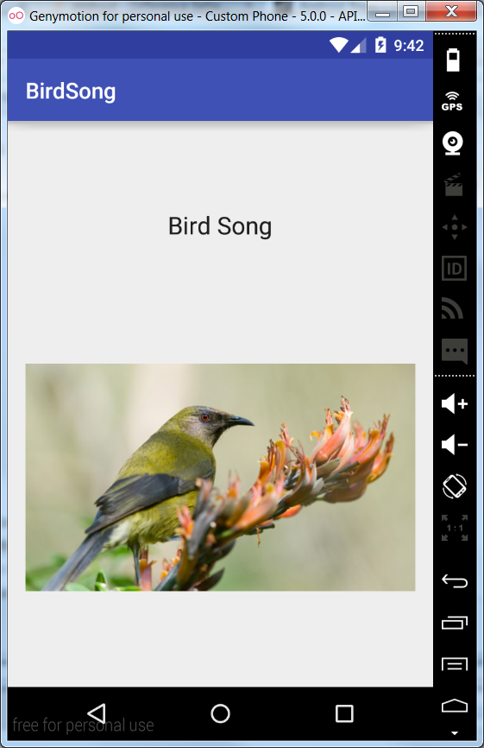
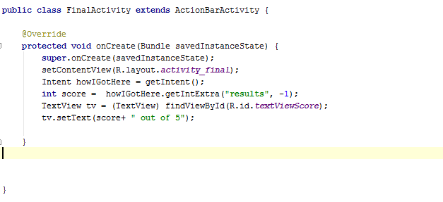

Task 2:

In this app the user clicks on the image and a sound file plays

